How soldering PCB for Drone controller

You may need before do:

List necessary components

|  |  |  |  |  |
| --- | --- | --- | --- | --- |
| Name of components | Qty. (pcs) | Number components in PCB | Remark | Link to ordering components |
| Diode M7 | 1 | D1 |  |  |
| Resistor 1.5 kohm with size SMD1206 | 1 | R1 | Size SMD with code 1206 |  |
| Resistor 1 kohm with size SMD1206 | 1 | R2 | Size SMD with code 1206 |  |
| Ceramic capacitor with size SMD1206 | 1 | C1 | Size SMD with code 1206 |  |
| Electric capacitor 470 µF | 1 | C2 | Or any capacitor with recommend more than 220 µF. And minimal voltage requirement more 16 V. |  |
| L7805 voltage regulator | 1 | 7805 |  |  |
| MPU6050 gyroscope board | 1 | U2 |  |  |
| Arduino nano | 1 | ARD1 |  |  |
| Buzzer with generator, which it compuse less than 40 mA and normal voltage 5 V | 1 | U3 |  |  |
| PCB with provided circuit | 1 |  |  |  |
| 2.54mm 3-pin header male with angle 90° | 4 | With short text about ESC | For connect each ESC to flight controller |  |
| Wire with female header 2.54 mm | 6 (with mixed color of wires) | U1 | For receiver Fly-sky |  |

1. Solder SMD-components, which resistor and capacitor with following normal value and number of places of this PCB.

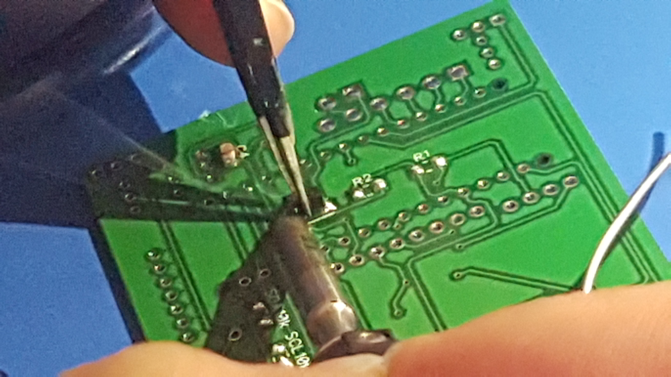

1. Solder electric capacitor and buzzer, but it is very important follow polarity where marked symbol “+” – plus polarity. Otherwise polarity, may be damage these components.

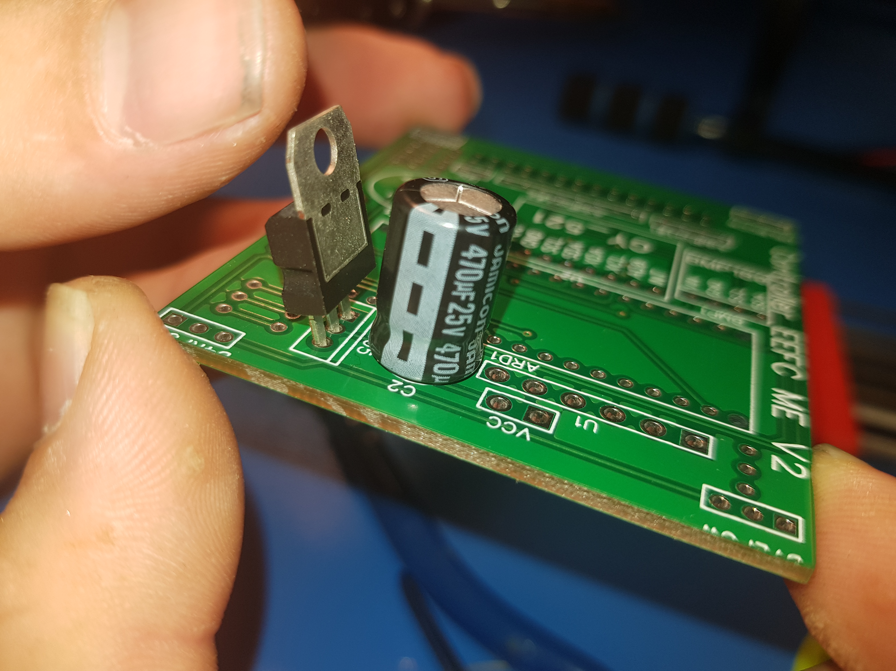

1. Solder L7805 voltage regular. Follow correct pin of L7805 into board. Follow picture.

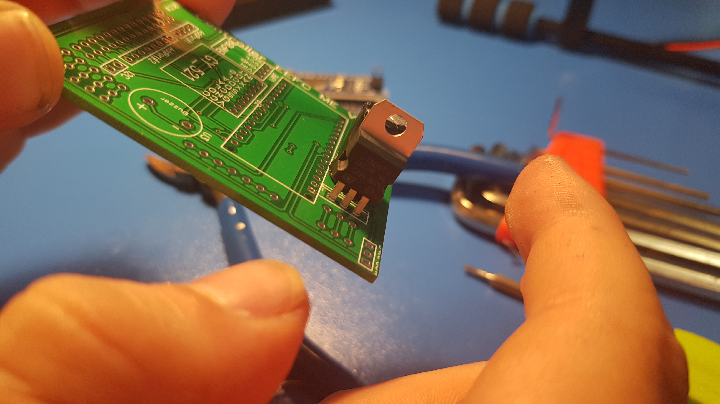

1. Solder wires for receiver Fly-sky. If you have two header female in each wire, cut one this header of wire. Clear bit part isolation of each wire. Solder wire into board with following number of components.

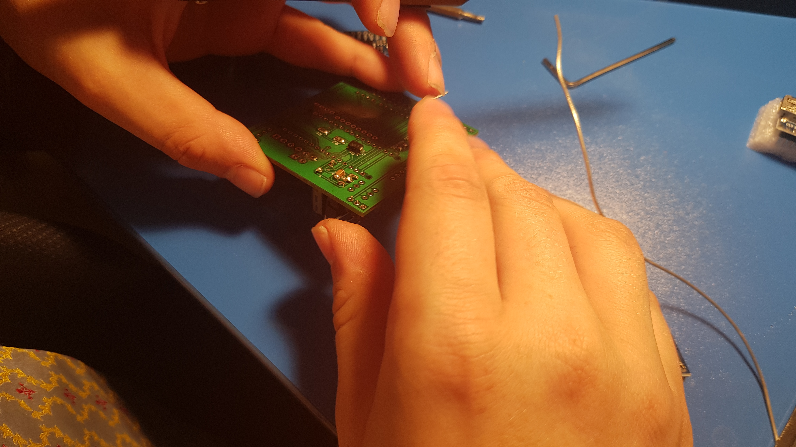

1. Gyroscope and Arduino nano controller provided header male with apporation number of pins.
   1. First solder header into these boards.

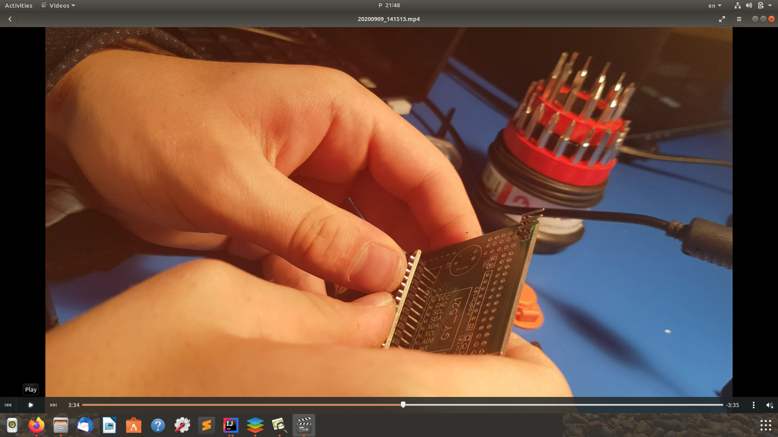

* 1. Pick these modules into PCB, but you need make sure correct pin before soldering. Follow this picture below. Be carefully! Otherwise, board may death if incorrect pick module into board. You may need to check correctly pin via multimeter. Simple test polarity between modules and PCB.
  2. Recheck your soldered board, before connect power, include pins for receiver and ESC. Sometimes don’t marked polarity in PCB. You can find polarity via multimeter where it is plus and minus, pin, signal. Follow picture below.

